**Book Management System-(Group No.23)**

Guide :- Made by:

Mrs. SHILPA MAM Bagwan Shahabaz Shakil (223032)

Mrs. MEGHA MAM Nalawade Shubham Mugutrao (223121)

**ER Diagram :-**

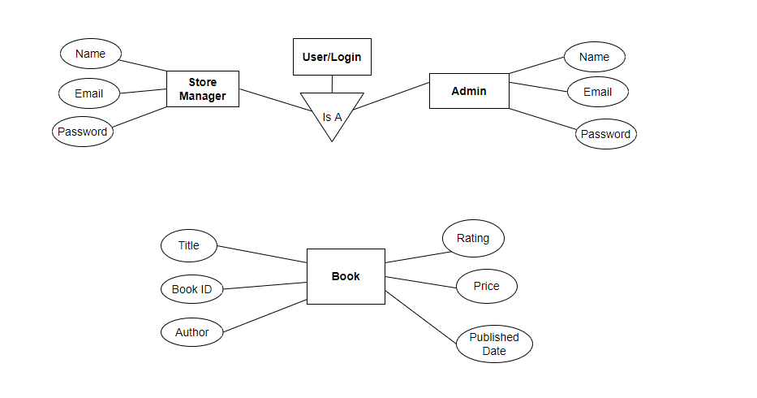

**Table Structure:-**

**User Table:**

|  |  |  |  |  |
| --- | --- | --- | --- | --- |
| **Field** | **Type** | **Null** | **Key** | **Extra** |
| User_Id | Int | No | Primary | Auto_Increment |
| User_Name | Varchar(30) | No |  |  |
| Email_Id | Varchar(30) | No | Unique |  |
| Password | Varchar(30) | No |  |  |
| ContactNo | Varchar(30) | No |  |  |
| Address | Varchar(30) |  |  |  |
| User_Role | Varchar(30) | No |  | In(Admin,Manager,) |

**Book Table :**

|  |  |  |  |  |
| --- | --- | --- | --- | --- |
| **Field** | **Type** | **Null** | **Key** | **Extra** |
| Book Id | Integer(30) | No | Primary | Auto_Increment |
| Book Name | Varchar(30) | No |  |  |
| Author | Varchar(30) | No |  |  |
| Book Rating | Varchar(10) | No |  |  |
| Price | Double(30) | No |  |  |
| AvailableQty | Integer(30) | No |  |  |
| Published Date | String(30) | No |  |  |

**Data Flow Diagram(DFD) :-**

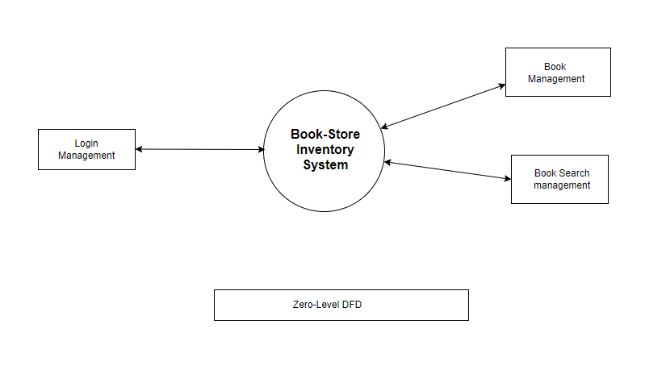

**Zero level DFD**

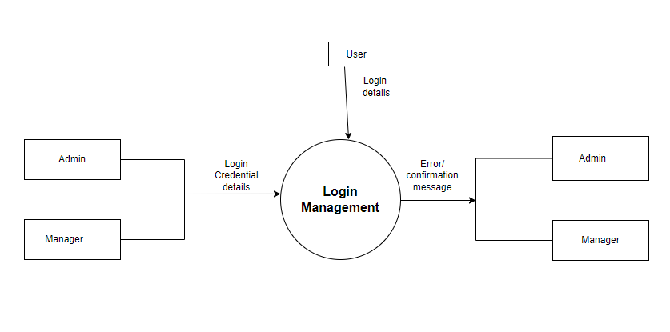

**First Level DFD**

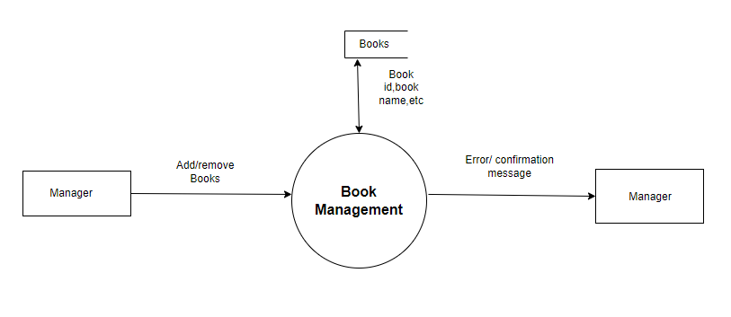

**First Level DFD**

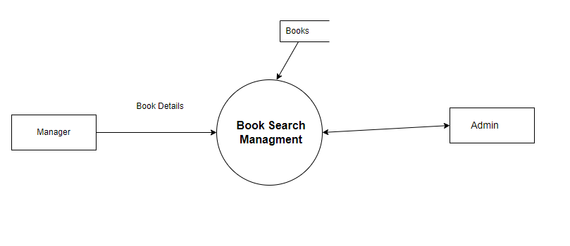

**First Level DFD**

**Use Case Diagram:-**

**1. Admin:**

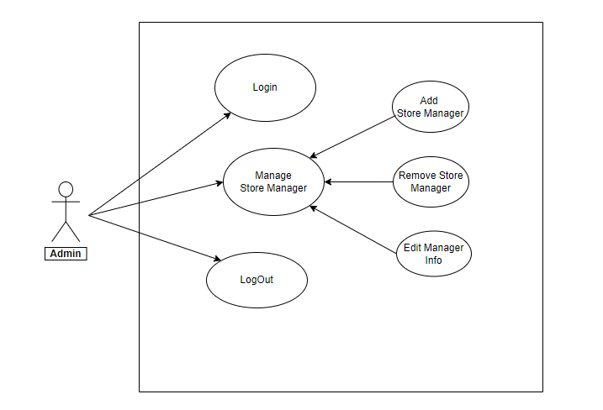

**2. Manager:**

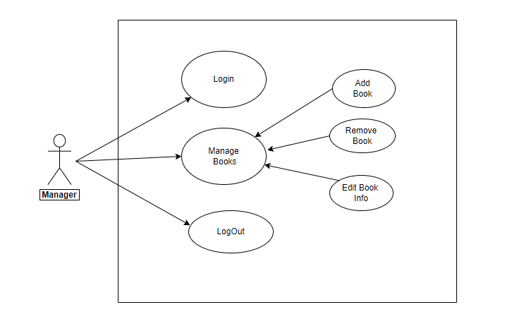

**Activity diagrams:-**

**1. Admin:**

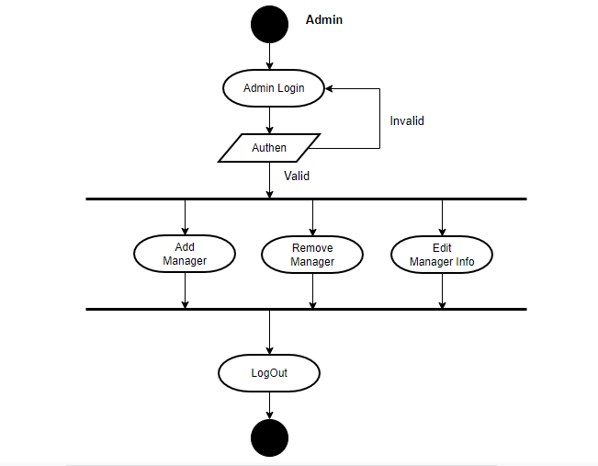

**2. Manager:**

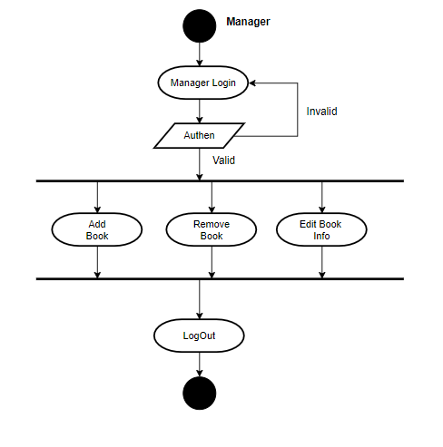

**Flowchart:-**

**1.Admin:**

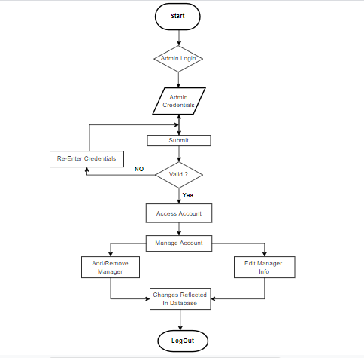

**2.Manager:**

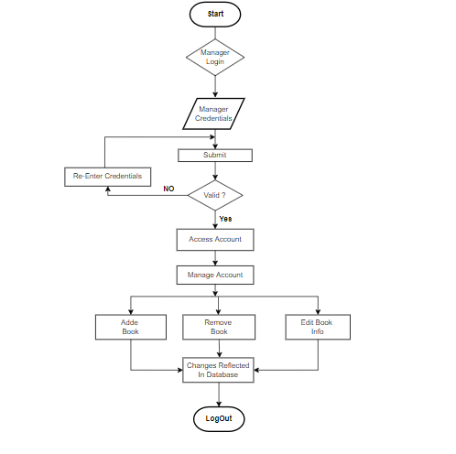

**Sequence Diagram:-**

**1. Admin:**

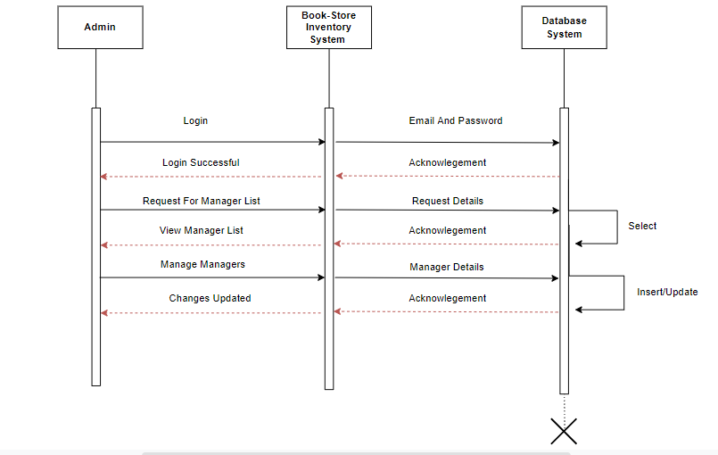

**2. Manager:**

